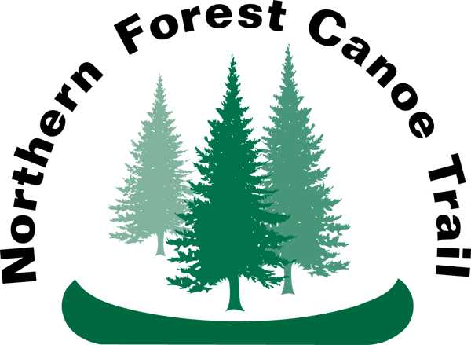
Northern Forest Canoe Trail
Stewardship Intern Application

Name:
Phone number:
Email address:
Hometown, state:
Date of birth:
School:
Degree (working towards or completed):
Current year if in school (freshman, sophomore, etc):

1. What inspired you to apply for this internship?

2. What outdoor activities are you proficient in?

3. Describe your prior paddling experience.

4. What are your career goals?

5. What skills and experiences do you hope to gain through a stewardship internship with NFCT?

6. How would you describe your personality and working style?

7. Please summarize your previous teamwork and leadership experience.

8. Describe your experiences with hands-on physical work, field based projects, and work with tools.

9. What do you think are the most important contributions you can make to the Stewardship Internship program?

10. Are you currently Wilderness First Aid Certified? If not, are you willing to gain certification before the start of the NFCT field season?

11. Have you spent a week camping before? If so, give examples. If not, explain why you would be comfortable camping out for a week’s duration.

12. This year, we are building two teams of interns. Our roving team will work on projects from New York to Maine. Our Allagash team will be based in heart of a wilderness waterway in northern Maine. Please share if you are interested in one or both positions, if there is a position you’d prefer, and why.

13. If needed, could you have access to a personal vehicle this summer?

14. Anything else you want to tell us about yourself?

