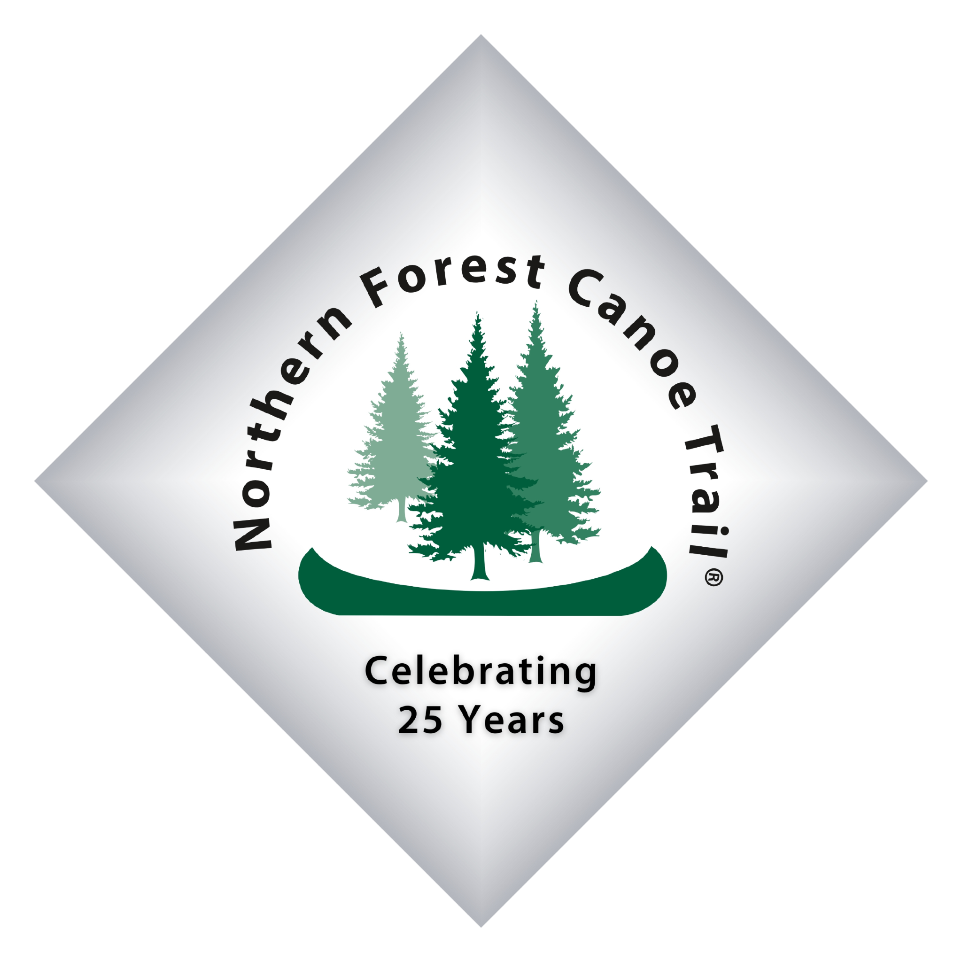

**FOR IMMEDIATE RELEASE**

Tuesday, July 8, 2025

**FOR MORE INFORMATION**

Chris Morris

[chris@northernforestcanoetrail.org](mailto:chris@northernforestcanoetrail.org)

(802) 496-2285 ext. 4

**Flood recovery continues with Lamoille River cleanup**

*NFCT, volunteers team up to remove trash from river corridor*

WOLCOTT, Vt. — A crew of professional stewardship staff and community volunteers partnered in June to haul trash out of the Lamoille River.

The cleanup, organized by the Northern Forest Canoe Trail (NFCT), was part of ongoing recovery efforts following severe flooding from the last several years. The work was carried out in partnership with the Lamoille River Paddlers Trail and funded in part by a Flood Recovery Grant from the Vermont Outdoor Recreation Economic Collaborative (VOREC).

“The Lamoille River is one of Vermont’s greatest natural resources,” said Alex Delhagen, the NFCT’s assistant trail director. “It’s ecologically important as part of the Lake Champlain Basin and provides an economic impact to the communities it passes through, as it provides fantastic recreation opportunities for paddlers, anglers, swimmers and more. We’re committed to doing our part to restore it to a more pristine state.”

The focus of this year’s river cleanup was the Wolcott area. While previous cleanups targeted smaller debris along the corridor, most of which was removable by canoe, this year’s work saw crews remove larger items, including refrigerators, fuel tanks and barrels. The NFCT contracted with a trash removal service to dispose of the items properly.

In addition to the cleanup, the NFCT facilitated a community paddle-pedal event along the Lamoille in Johnson, Vt.

As the only dedicated water trail crew in the Northeast, the NFCT’s stewardship crew specializes in projects at the interface of land and water, including campsites, portage trails and access points. The NFCT’s roving crew works in New York, Vermont, New Hampshire and Maine throughout the paddling season; a second crew is based in the Allagash.

To learn more about the NFCT’s stewardship work, including volunteer opportunities, contact Trail Director Noah Pollock at [noah@northernforestcanoetrail.org](mailto:noah@northernforestcanoetrail.org). For more information about the NFCT, visit northernforestcanoetrail.org.

**About the Northern Forest Canoe Trail**

The Northern Forest Canoe Trail is a nonprofit organization that maintains and promotes the 740-mile water trail that traverses historic travel routes from Old Forge, NY, to Fort Kent, Maine, and connects New York, Vermont, Quebec, New Hampshire and Maine. The trail showcases the mix of landscapes and communities currently lining the traditional routes used by Indigenous peoples, settlers and guides. It is the longest in-land water trail in the nation and consists of 23 rivers and streams, 59 lakes and ponds, 45 communities and 65 portages. To learn more, visit northernforestcanoetrail.org.